**Task : Setup minikube at your local and explore creating namespaces**

**Setting up Kubectl and minikube in local :**

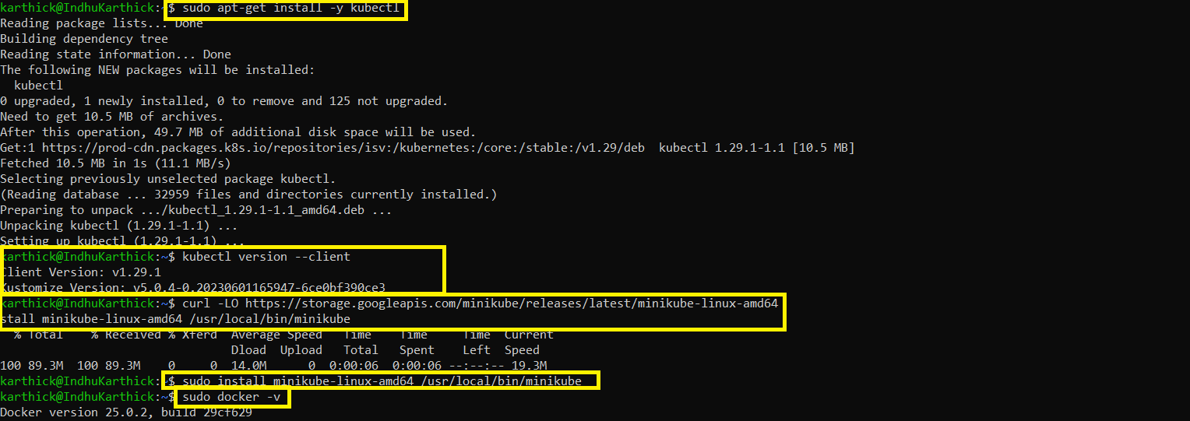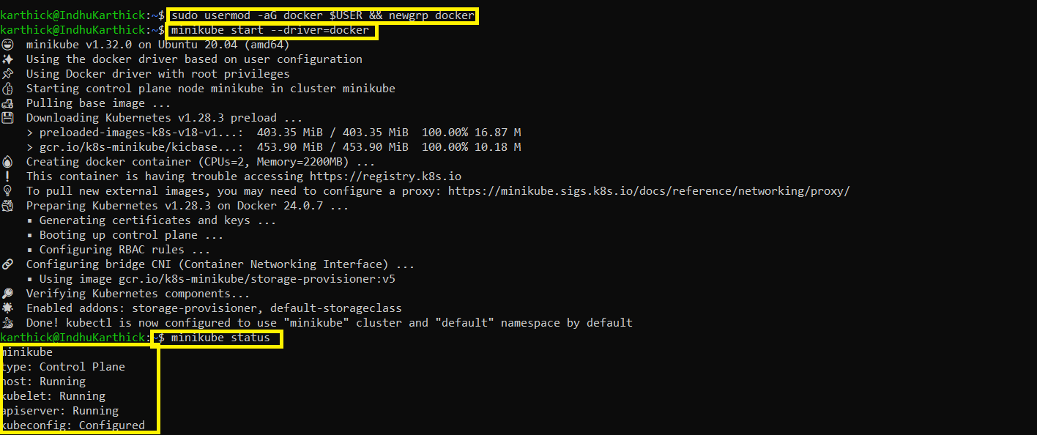

**Kubectl commands, creating namespaces and exploring :**

